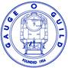
Members Inventory of Stock
Model Railway Estates Service
Contact MRE@gaugeoguild.com or Phone MRE advisor Kevin on 07519 500990

Scale | Qty | Description | Company Livery | Manufacturer | DCC / Sound | Motor / Gearbox | Weathering | Comments | Price Insured / Expected | Unique  Photo No.

